

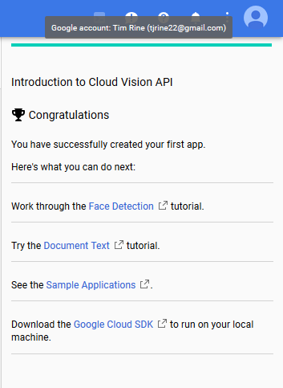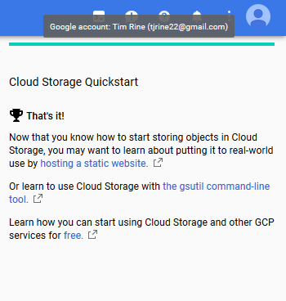

Timothy Rine

ISDS 4120

Dr. Schwarz

Hands-On Assignment #10

April 19th, 2018

Here are the screenshots of the completion of each of the three tutorials for this weeks assignment.